MEDIA RELEASE
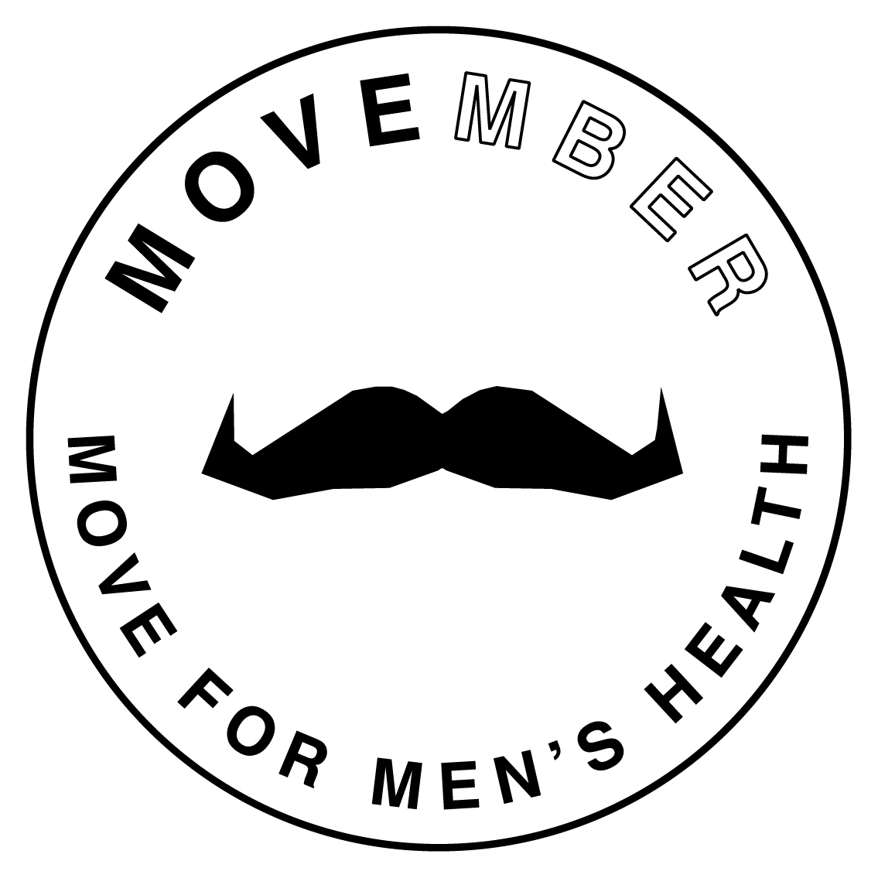

Movember’s got a new MOVE
We talk the talk now it’s time to walk the walk. Grow your Mo. Get moving. Do Movember.
26 October 2015: From the team who put the moustache back on the face of fashion comes MOVE, a 30-day fitness challenge to raise funds and awareness for men’s health.
We’ll always be all about the moustache, but now there’s more than one way to champion men’s health in Movember. For Mo Sistas, MOVE is a way to do something tangible in the name of men’s health, and for Mo Bros it’s a new challenge. Grow your Mo, MOVE, or take things to the next level and do both.
MOVE is a new way to make a difference this Movember. We’re challenging people to MOVE every day of Movember. 30 MOVEs in 30 days.
How you MOVE each day is up to you. Whether it’s a work out one day, a quick jog at lunchtime the next, an hour at the ping-pong table, or an epic bike ride, no MOVE is too big or small. Just sign up at Movember.com and commit to MOVE for men’s health.
Being active is one of the best things you can do for your health. Too many of us spend far too long sitting in front of a computer, a TV, or in transit. Our bodies just weren’t designed to sit for that long and studies show that all this sitting is taking a major toll on our health – sitting has become the new smoking.
The good news – moving on a regular basis can reduce your risk of heart disease, diabetes, and cancer by up to 50% and lower your risk of early death by up to 30%. It’s also one of the best ways to stay mentally healthy and one of the best treatments for mild to moderate depression.
MOVE is directly linked to Movember's vision of having an everlasting impact on the face of men’s health. A world where men live happier, healthier and longer lives, starts with simply moving. The moustache starts a conversation about men's health and MOVE puts our vision into immediate action.
We all know that exercise is good for us, but MOVE isn’t just about fitness. It’s about shaking up the routine. Trying something new. Moving in unusual ways. Challenging yourself. Getting your friends on board. Doing something good for you and Men’s health.
So, this Movember, be a champion of men’s health by starting your own movement. Walk the walk, talk the talk. Run the run. Swim the swim. Join the movement.

1. Sign up at movember.com and join the movement.
2. MOVE every day for the 30 days of Movember.
3. Challenge your friends to match your MOVEs.
4. Share updates throughout the month.
5. Raise vital funds for men’s health initiatives.

ENDS

Social media channels:
#tag: #MovemberRSA
Facebook: https://www.facebook.com/MovemberSouthAfrica
Twitter: @MovemberRSA

Issued by: Magna Carta PR
Nabiella De Beer
nabiella@magna-carta.co.za
087 997 0111

On behalf of: Movember/ Men’s Foundation

