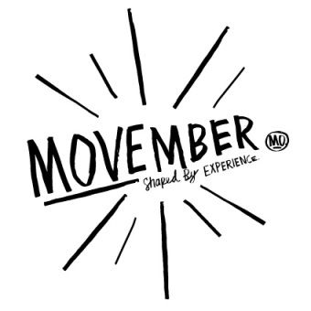
MEDIA RELEASE

What a moustache says about you, and a beard doesn’t’….

28 October 2015: You’ve heard and read the story….’It started in a bar in Fitzroy in 2004, two mates talking about the fashion trends that hadn’t returned…and the moustache was one…’

In case you hadn’t heard of how the biggest men’s health movement of our time had started, to date raising over ZAR 4 Billion since inception and investing into over 831 programmes, you’ve probably not been called a Mo Bro or Mo Sista, or joined 1 of the over 4m people globally who have signed up to participate in this annual campaign since 2004, which prides itself on ‘Changing the Face of Men’s Health’ each November.

The culprit, the Moustache, or mo – whether the boxcar, the wisp, undercover brother or Rock star – it’s become a symbol of men’s health and the Movember campaign on the faces in 21 countries over the past 12 years.

This Movember, we’re paying homage to the moustache, during a trend where top-knots and beards are common place, it’s the ultimate sacrifice in the face of men’s health – the beard sacrifice, and as the moustache has proven to achieve with over 1.7 Billion conversations generated around Men’s Health and has become the equivalent of the ‘pink ribbon’ to breast cancer.

While it takes a brave man to grow a beard, it takes a braver man to give up his beard in the name of men’s health – and as the Movember rules state, start 1 Movember clean shaven, and groom and grow a mo for the month. Whether you have been growing your beard for years or recently joined the trend for the follicley-blessed, by making the change from beard-growing to moustache-growing for the month.

The act of sacrificing your beard, and refining your upper lip, creates much needed conversation around the often ignored issues of men’s health. Let people know you took it all off to raise awareness and funds for prostate and testicular cancer along with male mental health and physical inactivity, and get your friends and family to donate to your Mo Space (your profile on movember.com).

#Livewithheart this Movember, sacrifice your beard and motivate why you support men’s health, including Prostate and Testicular Cancers, as well as male mental health issues and you could win R5000 for yourself and R 5000 for your Mo Space page, resulting in you automatically joining the Movember platinum club, as well as an exclusive product hamper from The Captain’s Beard.

To qualify, simply Sign up and join the Team ‘Beard Sacrifice’ on www.movember.com , creating your own mo-space and listing your motivation and reasoning for sacrificing your beard on your team mo space page, age and starting clean shaven on 1 Movember to grow and groom a mo for Movember. Upload a pic to Facebook, Instagram or Twitter and tag Movember while using the hashtag #LivewithHeart. Entries close on November 30th 2015.

The Movember Foundation’s goal is for men to live happier, healthier and longer lives and the funds raised by the annual campaign go towards awareness campaigns as well as research and survivorship programmes developed in conjunction with Movember’s men’s health partners. By raising these funds and creating these much needed conversations, you can help break down the stigmas associated with male specific diseases and encourage men to be more aware of their health and to openly talk about concerns that they have.

Get checked, know your numbers, sign up, grow, give, move – join us! Together we can Change the Face of Men’s Health.

For more information, visit www.movember.com or download the Movember app on your mobile device. Follow Movember on social media: @MovemberRSA on Twitter or facebook/MovemberSouthAfrica.

ENDS

Social media channels:
#tag: #MovemberRSA
Facebook: https://www.facebook.com/MovemberSouthAfrica
Twitter: @MovemberRSA

Issued by: Magna Carta PR
Nabiella De Beer
nabiella@magna-carta.co.za
087 997 0111

On behalf of: Movember South Africa

