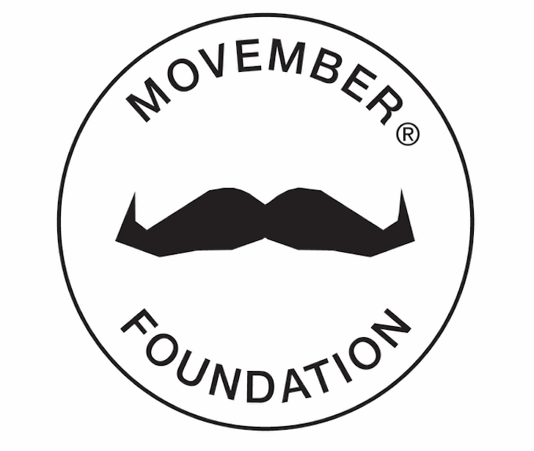

MEN ARE WILLING TO TALK, IF YOU ASK:
MOVEMBER’S UNMUTE – ASK HIM CAMPAIGN URGES YOU TO SUPPORT MENTAL WELLNESS BY ASKING THE MEN IN YOUR LIFE HOW THEY’RE DOING

It’s not always easy to know how a man is really doing, which is why the Movember Foundation is encouraging the people around men to take themselves off mute and ask a man if he’s doing O.K.

UK – (September 7, 2017) – In the lead up to World Suicide Prevention Day on September 10, leading men’s health charity the Movember Foundation is helping to ignite potentially life-saving conversations through their Unmute – Ask him campaign.
In addition to funding more than 1,200 innovative men’s health projects across 21 countries focused on prostate cancer, testicular cancer, mental health and suicide prevention, the Foundation is also shedding light on the role of men’s support networks – family, friends and partners – who can help men to remain mentally well through practicing active listening and maintaining social connections.

Now live as of September 7, Unmute – Ask him signals the start of a month-long campaign by Movember to encourage open conversations around men’s mental health as a way to ultimately reduce the high rate of male suicide.
Disguised as a series of how-to videos where a man takes the viewer through simple tasks, such as ’Fix a Flat,’ ‘Make a soda can fishing rod,’ and ‘Never run out of a gas again with this simple trick’ – each video demonstrates the importance of taking the initiative to ask men how they are doing, and not just assuming everything is O.K.
While the video subtitles appear to mirror the men’s actions, when the viewer unmutes, they’ll hear a completely different story – about men who are beginning to show signs they are struggling.

“Our research has shown that a majority of men say they are there for their friends when they need support, yet considerably fewer men are prepared to go to someone when they’re struggling themselves – bringing to life the need for those around men to take themselves off ‘mute’ and start the conversation,” says Craig Martin, Global Director, Mental Health & Suicide Prevention at the Movember Foundation.
“As part of our strategic vision to support men and boys being mentally healthy and taking action during tough times, backed by their friends, family and community, Movember is building capacity around men, to ensure more men talk and feel the benefits of being heard,” he said.
“The network around men currently do not reach out enough to ask how guys are really going. We can all play a part in reducing the rate of male suicide by sparking a potentially life-changing conversation – the simple first step is just to ask and listen.”
As well as encouraging people to share the Unmute – Ask him campaign videos on social media, Movember also wants people to start conversations with men they care about in just four simple steps:
- Ask how they are doing
- Listen without judgement
- Encourage action
- Check in regularly
The Movember Foundation’s suicide prevention campaign is a key strategic element of their goal to reduce the rate of male suicides by 25%, and ultimately, the number of men dying prematurely by 25%, by 2030.
To learn more about how you can effectively help the men in your life open up and to view and share the Unmute – Ask him videos visit www.movember.com/iwanttoask.

About the Movember Foundation
The Movember Foundation is the only global charity focused solely on men’s health, funding over 1,200 innovative projects across 21 countries. To date, they have raised hundreds of millions for men’s health programs supporting these critical areas: prostate cancer, testicular cancer, mental health and suicide prevention. Go to Movember.com to donate or participate.

Globally and locally, the Movember Foundation is making progress with mental health and suicide prevention projects, in collaboration with local men’s health partners, to reach men all over the world and promote healthy actions and behaviors. These initiatives include:
- Social Innovations Challenge (UK, AUS, CA)
  - Launching this September, 13 projects across three countries will take a range of innovative approaches to help men build and maintain quality social connections and a sense of belonging, in order to reduce the risk of social isolation and loneliness.
- Making Connections (US)
- NewAccess (AUS)
- Like Father Like Son (AU)
- Farmstrong (NZ)
- MAN/ART/ACTION Tribute Pole (CA)

PRESS CONTACT:

Lisa Potter, Global Director PR & Communications

lisa@movember.com / +1 310 450 3331

Cara Thomas, Senior Account Manager

cara.thomas@ketchum.com / 0203 755 6424

