MOVEMBER COMMUNITY PRESENTATION
Speaking notes

Slide 1 - Movember Foundation
- Thanks for having me.
- Last year our team had *** Mo Bros and Mo Sistas that have raised $ (if applicable), thank you!
- All part of the over 75,000 Mo Bros and Mo Sistas that raised $17 million.
- Now’s a time for building a team and that’s what I’m here for, to help you understand how, but also know the amazing things Movember is up to with your funds.

Slide 2 - Who We Are
- The best part of Movember is how it began.
- Most charities start with a cause and build a fundraising or awareness campaign around it.
- Movember started with fun and added in the charitable piece after.
- In 2003, there were two guys sitting at a bar in Melbourne Australia talking about things that had gone out of style. They eventually thought of the moustache and made a commitment to bring the moustache back onto the face of fashion. The two friends agreed to rally 30 of their friends, grow a moustache for 30 days and celebrated their hairy journey with a party at the end. They gave awards for best and worst moustache and had an amazing time celebrating their hairy journey. But that was it. It was just for fun amongst 30 friends… with moustaches.
- Movember didn’t start as a charitable effort, and they certainly didn’t think that they would change the world, but the original 30 knew that they were on to a great idea…
- Despite all the slack from their friends and family about how awful their moustaches were, the group had a lot of fun and realized that they had created something special. But they knew they needed to find a way to legitimize their efforts.
- The founding members had a conversation and wondered if the moustache could do for men’s health what the pink ribbon had done for women’s health?
- - Prostate cancer was the men’s equivalent to breast cancer, except no one was funding it, talking about it or aware of it. So that’s what they did. They married the moustache and prostate cancer.
- The second year of Movember raised $54,000 for the Prostate Cancer Foundation of Australia- the single largest donation they had ever received.
- In 2007, Movember hopped over to North America and has continued to grow into the largest men’s health charity in the world.
Slide 3- Numbers
- Since 2003, The Movember Foundation has had over 5 million Mo Bros and Mo Sistas raise over $850 million across the world, which has translated into over 1000 men’s health projects.
- $175 million of that has come from Canada and has funded over 230 projects throughout the country.
- The Movember Foundation and our community of Mo Bros and Mo Sistas has absolutely changed the game for men’s health!

Slide 4 - Intro Video

Slide 5 - The State of Men’s Health
- Let’s talk about the state of men’s health, despite Movember moving the dial in incredible ways - there’s a silent crisis going on with men.
- Gender is one of the strongest and most consistent predictors of health and life expectancy.
- Men die an average of 6 years earlier than women and there’s no biological reason for it.
- 3/4 deaths by suicide are men, same stat since 1955.
- The reasons for this are complex but not unsolvable. We can start by addressing some of the key health challenges facing men today and that leads directly into what we’re funding.

Slide 6 - Programs Slide - What areas we fund
- A good snapshot of some programs we’ve funded across Canada within our three pillars
- The Movember Foundation has always been holistically men’s health, but we focus on three areas that we know need the most work:
  - Prostate Cancer
  - Testicular Cancer
  - Mental Health & Suicide Prevention
- We began with Prostate Cancer because it was, and is, the biggest concern for men’s health
- We now have the ability to sufficiently fund prostate cancer research and programs, but also look into the other most pressing concerns for men’s heath and that is where our three focus areas come from.

Slide 7 – Prostate Cancer
- The Issue:
- Prostate Cancer is the #1 diagnosed cancer among men
- The male equivalent of breast cancer, but no one was addressing or talking about it
- Where Your Money Goes:
- Movember is investing in cutting edge research & improving treatment care
- What Men Should Do:
- Early detection significantly increases survival rate:
  - If over 50 years old, take action and talk to your doctor about having a PSA test
  - If over 45 years old AND you have family history, you should talk to your doctor about having a PSA test
  - If you are African or Caribbean, you are at greater risk. If over 45 years old, you should talk to your doctor about having a PSA test.

Slide 8 – Testicular Cancer + Know Thy Nuts video
- The Issue:
- Most common cancer in men 15-29
- The male equivalent of breast cancer, but no one was addressing or talking about it
- Where Your Money Goes:
- Movember is investing in biomedical research
- Improving treatment care
- What Men Should Do:
- Simple. We want guys to get to know what feels normal for them and check in with their doctors if anything doesn’t feel quite right.

Slide 9 – Mental Health & Suicide Prevention
- The Issue:
- Globally, the rate of suicide is alarmingly high, particularly in men and the numbers are rising.
- 3 out of 4 suicides are men
- Mental health issues are complex, but not unsolvable.
- Where Your Money Goes:
- Undertaking campaigns and initiatives, leveraging the strengths of masculinity that lead to mentally healthy men, boys healthy relationships and communities.
- We’re working to foster and promote social connections amongst men, so that when things get tough, they have people in their lives they feel safe talking to
- Ex. see next slide which shows the Movember “Suicide Notes Talk Too Late” campaign video
- What Men Should Do:
- Stay socially connected. Spend time with your friends, it’s good for you.
- Talking, listening and being there for someone can be lifesaving.
- Stuff happens in life, often beyond our controls – it’s normal to feel overwhelmed if you’re tackling it alone. Share what’s going on, talk to someone.

Slide 10 – Suicide Notes Talk Too Late Video

Slide 11 – A Program in Action - Bro Talk
- Movember funded Kids Help Phone (KHP) for $3 million in 2014
- KHP approached Movember with an issue that they were having: young mean over 12 years old were not calling in anymore.
- They discovered that the problem wasn’t that those children didn’t have any issues to phone in about, but rather that they didn’t see themselves as “kids” anymore.
- The solution was to creat Bro Talk
  - Bro Talk is a free, confidential and online service that provides counselling and information to help teen guys tackle their challenges and stresses, big or small. Chat online or over the phone.
  - Hours available from 6pm – 2am, Mon-Fri
  - Young men can chat online or phone and talk about anything they want
  - (Above photo a screen shot from website landing page)

Slide 12 – The Power of the Moustache
- Men growing moustaches become walking, talking billboards for men’s health. The best part about Movember is that before a dollar is raised…1000’s of men across Canada and the world are growing moustaches and starting conversations that are changing people’s lives. This is called the “power of the moustache.”
- Eg. 20 year old young man that reads how to check for testicular cancer on the Movember UK Facebook page. He gives himself a feel and finds a lump. A few weeks later he’s having it removed and here with us today because of it - Read email below

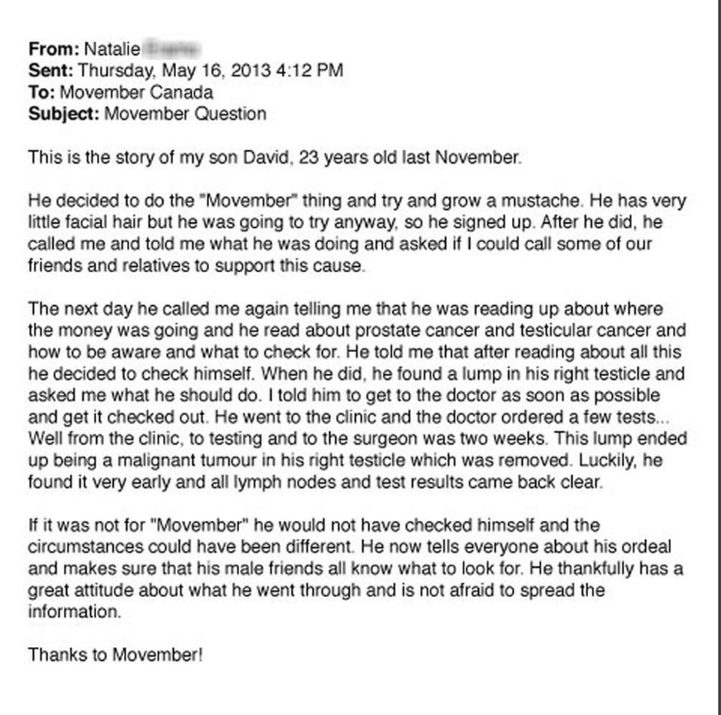
- If only one story like this happens a year, we know we’re doing something right

Slide 13 – Our Ambition
- The Movember Foundations goal is simple, we want to do everything we can to ensure that men live happier, healthier and longer lives
- To do that we’re committed to:
  - We’ll halve the life expectancy gap between men and women.
  - Halve the number of deaths from prostate cancer & testicular cancer by 2030
  - Immediately stopping the increase in suicide rates
- In order to do that, we are encouraging men to stand up, take care of their health, get into their doctor, share their feelings, understand when they need help and to take action and ask for help when they need it
- What we need to make sure is that if we’re encouraging men to build up the courage to ask for help, that we ensure there are resources in place to be there for them when they do
- And that’s where all the funds you all raise come in

Slide 14 – There’s More To Be Done

- In 14 years we’ve raised more than $750 million and funded more than a thousand projects, from ground- breaking genome research to on-the-ground health services reaching at-risk men. We’ve advanced prostate cancer research 50 years, inspiring men and women around the world take up the cause to shape change. We’ve made huge strides—but there’s more to be done.
- The challenges facing men are complex. Traditional ways of approaching these problems aren’t enough. That’s why we’re shaking things up.
- Our ambitions are big, and we’ve got what it takes to make them happen. It’s all made possible by the incredible support of the global movement we’ve started.
- We want you to join the movement and help change the face of men’s health. Without people like you talking, taking action and giving money, nothing will change, and men will still die too young.
- Your donation could fund our next breakthrough.

Slide 15 – How to Participate
- Movember is for everyone. Join the movement of millions helping men live happier, healthier, longer lives.
- Give: We can’t do it without your donations. Visit movember.com to make a donation, or get in touch to organise a different way to give.
- Grow: Every year men worldwide grow their moustaches during the month of Movember. It’s our call to arms, our symbol and how it all started.
- MOVE: Take the challenge to get moving and raise funds. Push yourself. Run a marathon, climb a mountain or learn to swim.
- Host: Men and women worldwide host events of all shapes and sizes to raise funds for Movember. Do it anytime, anywhere, any way you like.
*Remember that the Movember Foundation is year round…so feel free to donate or hold any type of fundraiser for us throughout the year.

Slide 16 – Thank You & Contact
- Thank you and Mo on/Mo love
- Any questions?
- Contact Info

