Movember reveal 2020 campaign celebrity portraits starring Sir Mo Farah, Liam Payne, Sam Claflin, George The Poet, Peter Crouch and more

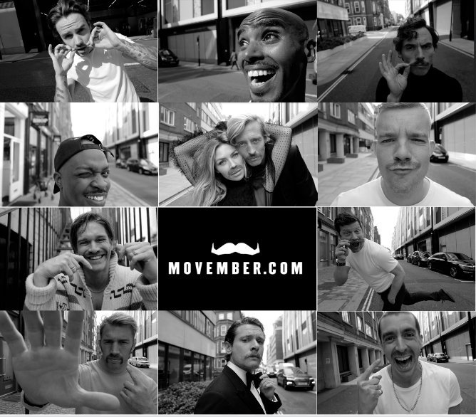

London, 19th October 2020: Leading men’s health charity Movember launches its 2020 campaign with a series of celebrity portraits directed and shot by acclaimed photographer, Greg Williams. Featuring Sir Mo Farah, Liam Payne, George The Poet, Peter Crouch, Abbey Clancy, Sam Claflin, Jack O’ Connell, Russell Tovey, Dermot O’Leary, Jesse Wood, Miles Kane and Chris Robshaw in a series of intimate and compelling portraits to help change the face of men’s health.
The portraits mark the start of the charity’s annual campaign, encouraging people to sign up and take part in Movember 2020 by growing a moustache, moving 60km in the month, hosting an event or taking on an epic challenge. However you Mo, it all helps support and shine a light on the critical work Movember does in men’s mental health and suicide prevention, testicular and prostate cancer.

In a bid to create more awareness around the current men’s health crisis, the charity has joined forces with Greg Williams to shoot a diverse and inspiring cast spanning sports, entertainment and music. The portraits aim to inspire everyone to come together for their fathers, partners, brothers, sons and friends at a time when looking after our health has never been more important. Every moustache grown kick-starts conversations, raises much-needed funds and awareness of men’s health issues – which ultimately saves lives.

This campaign comes at a crucial time, heightened by the pressures of a pandemic which has become not only a global health crisis, but a social and economic one too. Alarming new figures show that three out of four suicides in the UK are men, while the ONS reports an almost 50 percent increase in the rate of depression since the start of the pandemic.

Earlier this year, Movember research revealed eight out of 10 (83 per cent) British men find it helpful when people ask if they’re having a difficult time - yet nearly half (46 per cent) said no one had checked to find out how they were coping during the COVID-19 pandemic.

Worryingly, a third of men (33 per cent and 28 per cent respectively) reported feeling their relationships with work colleagues and friends had weakened since the physical distancing restrictions had been imposed.

Research also found more than a fifth of men (22 per cent) reported their mental health had worsened compared with before the outbreak of COVID-19 and a third (29 per cent) admitted they felt lonely more often.

And while the pandemic has put further strain on men’s mental health, other physical health issues facing men aren’t going away, either. Overall, men die nearly 6 years earlier than women. One in eight UK men will be diagnosed with prostate cancer in their lifetime, while testicular cancer is still the most commonly diagnosed cancer among young men.

Peter Crouch, said: “I’ve long supported Movember and the important work they do for prostate cancer, testicular cancer and male mental health. It’s been an honour to join the campaign this year and get behind the cause by growing a mo. This year more than ever, I urge everyone to get involved in the month-long movement and show your support in any way you can."

Abbey Clancy, said: “I am proud to be teaming up with Greg Williams alongside my husband Peter to raise vital awareness for Movember and the amazing work they do in futureproofing men's health. Many people assume Movember only supports men, but they also provide guidance for the support network of those who may be struggling. Whether you're a wife, partner, sister or mother, look out for the important men in your life and find out how to get involved at movember.com/2020."

Movember and the 2020 campaign stars call on the nation to get involved this year, and here’s how:
- Grow a moustache: Whatever you Grow will save a bro. Even if you can’t grow a showstopper, don’t worry: the worst moustaches start the best conversations.
- Move for Movember: Commit to running or walking 60km over the month. That’s 60km for the 60 men we lose to suicide each hour, every hour, across the world.
- Host a Mo-ment: Rally a crew and do something fun. Hosting is all about having a good time for a good cause.
- Mo Your Own Way: A choose-your-own-adventure challenge, epic in scope and scale. You make the rules. You set the limits and chase them down. You inspire donations with sheer grit.

Movember CEO, Michelle Terry commented: "It's great to see so many well-known faces put on a united front in support of men’s health, inspiring men and women to get involved and support our fundraising drive this Movember. This year has not been an easy one on many levels and the challenges are most likely to continue, impacting all areas of our life, including our health.
At Movember, we will continue to show up and support men during these times by being a voice for men’s health. We need to connect men and those around them, to provide tools and guidance on best how to take action on their health. We’re only going to be able to do this with continued support from the public.
We’ve seen men embrace facial hair during lock down and are now asking that they put that practise to good use and grow what could be, the most important Mo they ever grow."

To find out more and sign up, visit movember.com/2020.

-ENDS-
About Movember:
Movember is the leading charity changing the face of men’s health on a global scale, focusing on mental health and suicide prevention, prostate cancer and testicular cancer.

With money raised by its global community, Movember funds groundbreaking medical research, innovative cancer tests and treatments, and game-changing mental health interventions – over 1,250 men’s health projects around the world and counting. Along the way, millions have joined the movement.

In addition to tackling the key health issues faced by men, Movember’s mission is to motivate men to stay healthy in all areas of life, with an emphasis on social connection, talking more often and openly about their health, and reaching out in tough times.

Movember’s purpose is to change the face of men’s health. To learn more, sign up, or donate please visit movember.com.

